**CTfastrak Application**

**User Manual**

**Team VTD: Karthigaa Vijayakumar, Kevin Daley, Khuong Tong**

**Accessing the Application:**

Live Website: http://kvn-dly.github.io/

The web application has a live demo at the webpage linked above. Requirements for accessing the application are a modern webbrowser (Chrome, Firefox, Opera, and newer verions of Internet Explorer) and an internet connection. No installation, sign-up, or log-in required for use of this application. Simply access the website thru your browser. Below is a snapshot of the homescreen.

Address Entry

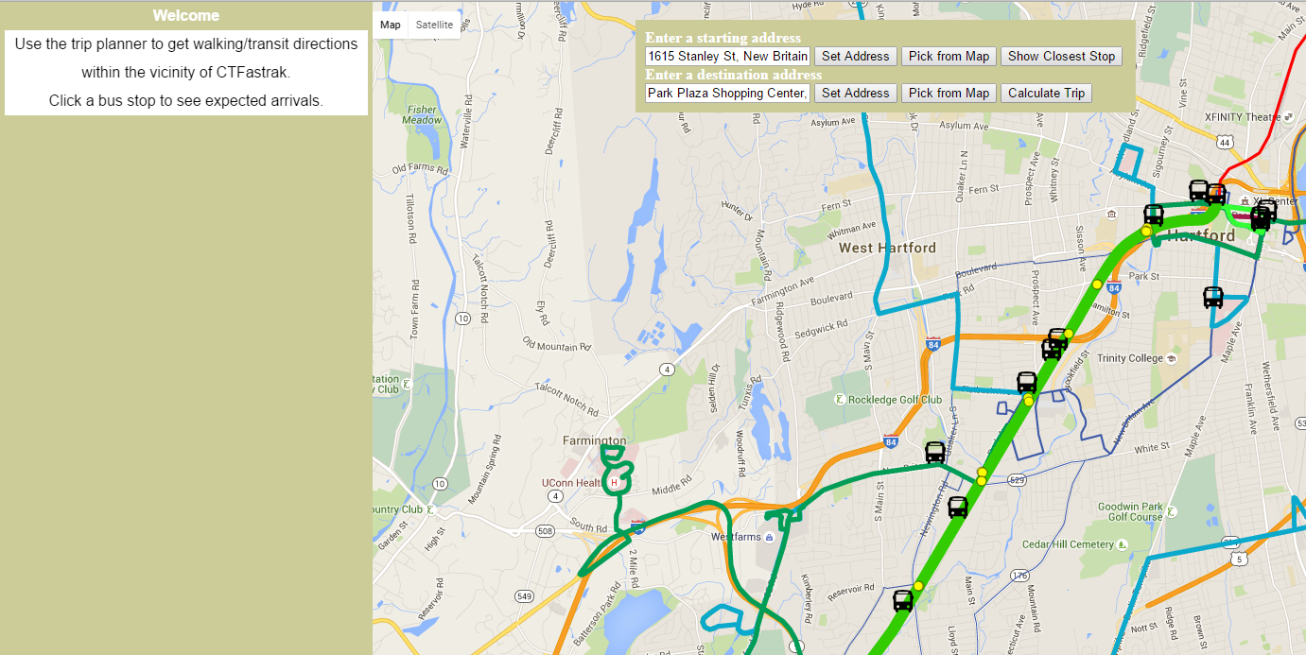

Live Map

Figure : Home Screen

Information Sidebar

**Main Features:**

Live Map - The locations of the CTfastrak buses are dynamically drawn on the map. Every 30 seconds the positions of the buses will automatically update.

Address Entry- The user may pick their location by clicking on a point on the map or they may type in their address. This allows the user to share their location and intended destination with the application.

Nearest Bus Stop - Users may search for the nearest CTfastrak bus stop to their location after they input their address.

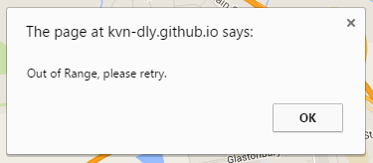Find a Route - The application can calculate a route using the CTfastrak line after a user has inputted their location and destination.

Out of Range - When picking a location from the map if the user is out of range they will receive an notice asking for re-entry.

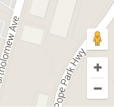Zoom/Pan - Users can freely pan through the map. Zoom in and out functions are located in the lower right hand corner.

Figure : Out of Range Notification

View Arrival Times - The user may click on one of the bus stops on the CTfastrak line to view the arrival times of buses. This information will display in the side bar.

View Schedules- The user may click on one of the bus lines to view more static information about that line. This information will display in the sidebar.

Figure : Zoom In and Out

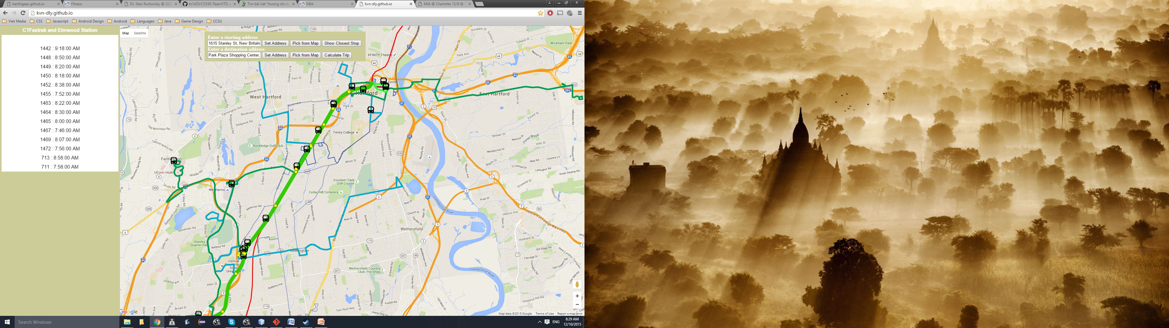

Click for more information about the line

Click for more information about arriving buses

Figure : Station and Line information

**Main Scenario:**

The user wants to find the route from one location to another near the CTfastrak line.

Steps:

1. Pick a starting point in on the map by first clicking "Pick from Map" and then clicking on to the map. A green circle will display if that location is in range.

2. Pick a destination in on the map by first clicking "Pick from Map" and then clicking on to the map. A blue circle will display if that location is in range.

3. Click on the calculate trip button to have the route displayed on the map and trip information shown in the side bar.

2a. Click to first before selecting destination

1a. Click to first before selecting starting point

1b. Click on starting point

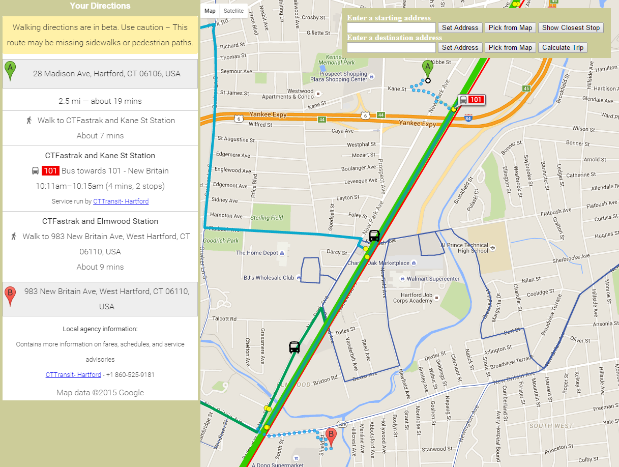

3. Click to display route

2b. Click on destination

Figure : Main Scenario Outcome

**Alternative Scenarios:**

User wants to locate the nearest CTfastrak station.

Steps:

1. The user enters their starting point in the address input bar and presses "Set Address".

2. The user clicks on "Show Closest Stop". The route will be displayed on the map and the directions are shown on the side bar.

1b. User clicks on set address

1a. User enters their address

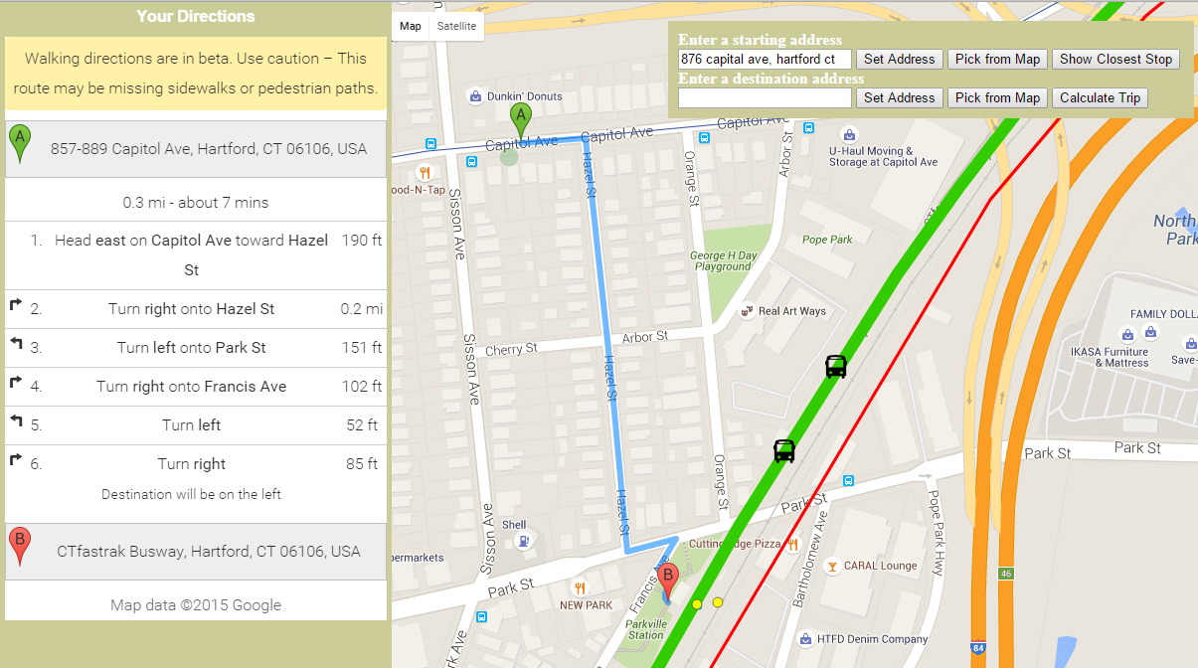

2. User clicks to show closest CTfastrak stop

Figure : Nearest CTfastrak Stop

User wants to see the location of CTfastrak buses.

Steps.

1. Open up the web application. The live map will automatically display the current bus locations. Buses will automatically update every thirty seconds.

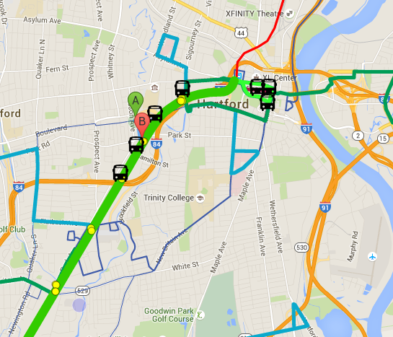

Figure : Current Bus Positions

User wants to view arrival times at a particular bus stop on the CTfastrak line.

Steps.

1. The user clicks on one of the bus stops on the line. Arrival times will be displayed on the side bar.

1. Click on a bus stop to view arrival times

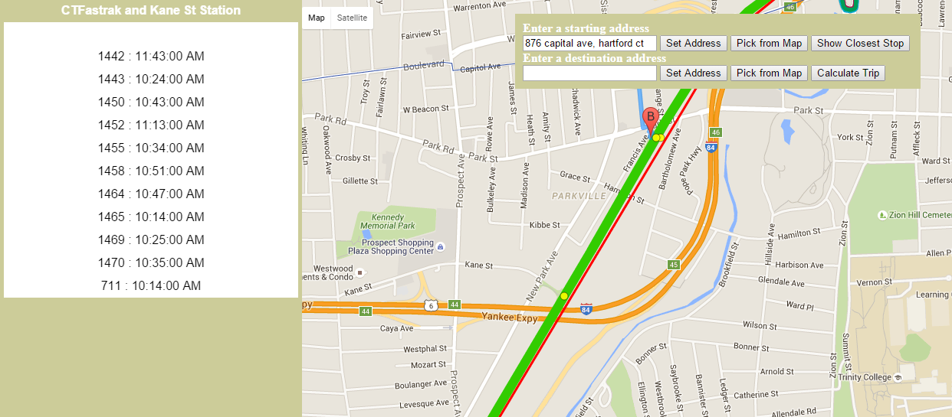

Figure : View Arrival Times